Copy these sentences out adding an appropriate adverb.

The snail crawled ___________ along the path.
The sun shone _______________ through the window.
The children in the choir sang ____________.
The twins played _____________ in the park.
The giant _____________ ate up all the cows in the field.
James ran ______________ and won the race.
The rain fell _______________ and we all got very wet.
You must play _______________ or someone will get hurt.
The witch _________________ turned Adam into a toad.
The dog ran _______________ after the ball.

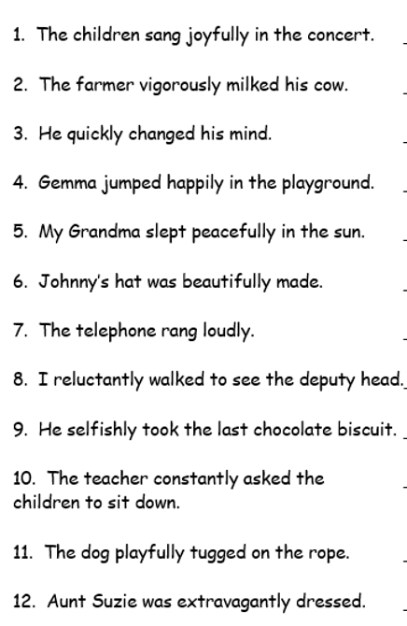
Find and write out the adverbs used in each of these sentences.

